Quantum and semi-classical transport in RTDs using NEMO 1-D
Gerhard Klimeck, Phillip Stout¹ and R. Chris Bowen
Jet Propulsion Laboratory, California Institute of Technology, Pasadena, CA 91109
¹CFDRC, Huntsville, AL 35899
email: gekco@jpl.nasa.gov website: http://hpc.jpl.nasa.gov/PEP/gekco
NEMO 1-D has been developed primarily for the simulation of resonant tunneling diodes (RTDs), and quantitative and predictive agreements with experimental high performance, high current density devices have been achieved in the past. There are four key ingredients to the success of these simulations: 1) the treatment of the extended contacts including quasi bound states and empirical relaxation time approximation scattering with a surface Green function, 2) accurate description of bandstructure using empirical tight binding models, 3) quantum charge self-consistency including a Hartree and exchange potential, and 4) the proper numerical integration over the transverse momentum.
The treatment of the contacts assumes that the device is subdivided into three distinct regions: 1/2) a left/right reservoir in local equilibrium with the left/right contact with well established left/right quasi-Fermi levels, and 3) a central device region which is treated to be in non-equilibrium using the non-equilibrium Green function formalism (NEGF). The central device region is considered to be the current limiting element in the device. The left/right reservoirs are assumed to be in local equilibrium with a flat Fermi level and conductive enough to provide current without depletion of the reservoir. Despite the successful comparisons to experiments one question remained lingering in the treatment of the reservoirs: How good is the assumption of a local equilibrium? or How good is the assumption of a flat Fermi level? The expansion of the NEMO 1-D code to couple a drift-diffusion model in the reservoirs to the central non-equilibrium region addresses these questions.
It can be shown that the drift diffusion equation can be formulated such that the current density in a particular device region is $J{\text{µm}}_{i}n_{i}{ÑE}_{F,i}$, where µ_{i}, n_{i}, and E_{F,i} are the device site (i) dependent mobility, electron density and quasi Fermi level). The expression holds for an arbitrary density of states for arbitrary electron distributions. Continually assuming that the central quantum region dominates the current flow in the device the spatially dependent quasi Fermi level in the left/right contact is computed iteratively with a quantum mechanically computed electron density.
This model is tested on a standard InGaAs/InAlAs RTD from the NEMO test matrix. Figure 1a shows potential profiles and corresponding quasi Fermi levels at a bias of 0.333V assuming two different constant contact mobilities: 10cm²/Vs and 20000cm²/Vs. A resistor-like drop in the potentials in the emitter is visible the lower mobility case. However, the overall effect in the device is more complicated than a simple series resistance voltage drop, since the Fermi level, the quantum mechanical electron density, and the potential profile are treated self-consistently with the current that is drawn out of the contact. This is particularly evident in the corresponding current-voltage characteristic in forward and reverse sweep are shown in Figure 2b. The peak current in the two curves (insert of 1b) differs between the two simulations, while a simple series resistance would simply shift the I-V curve. Also shown is the associated bi-stability, which increases with increasing contact resistence as expected. It is noted here that simulations using mobilities ranging from 20000 to 100cm²/Vs show almost indistinguishable results. A mobility of less than 100cm²/Vs, however, appears to be unreasonably low for these high performance devices and it can be concluded that a quasi Fermi level drop in the contacts appears to be negligible.
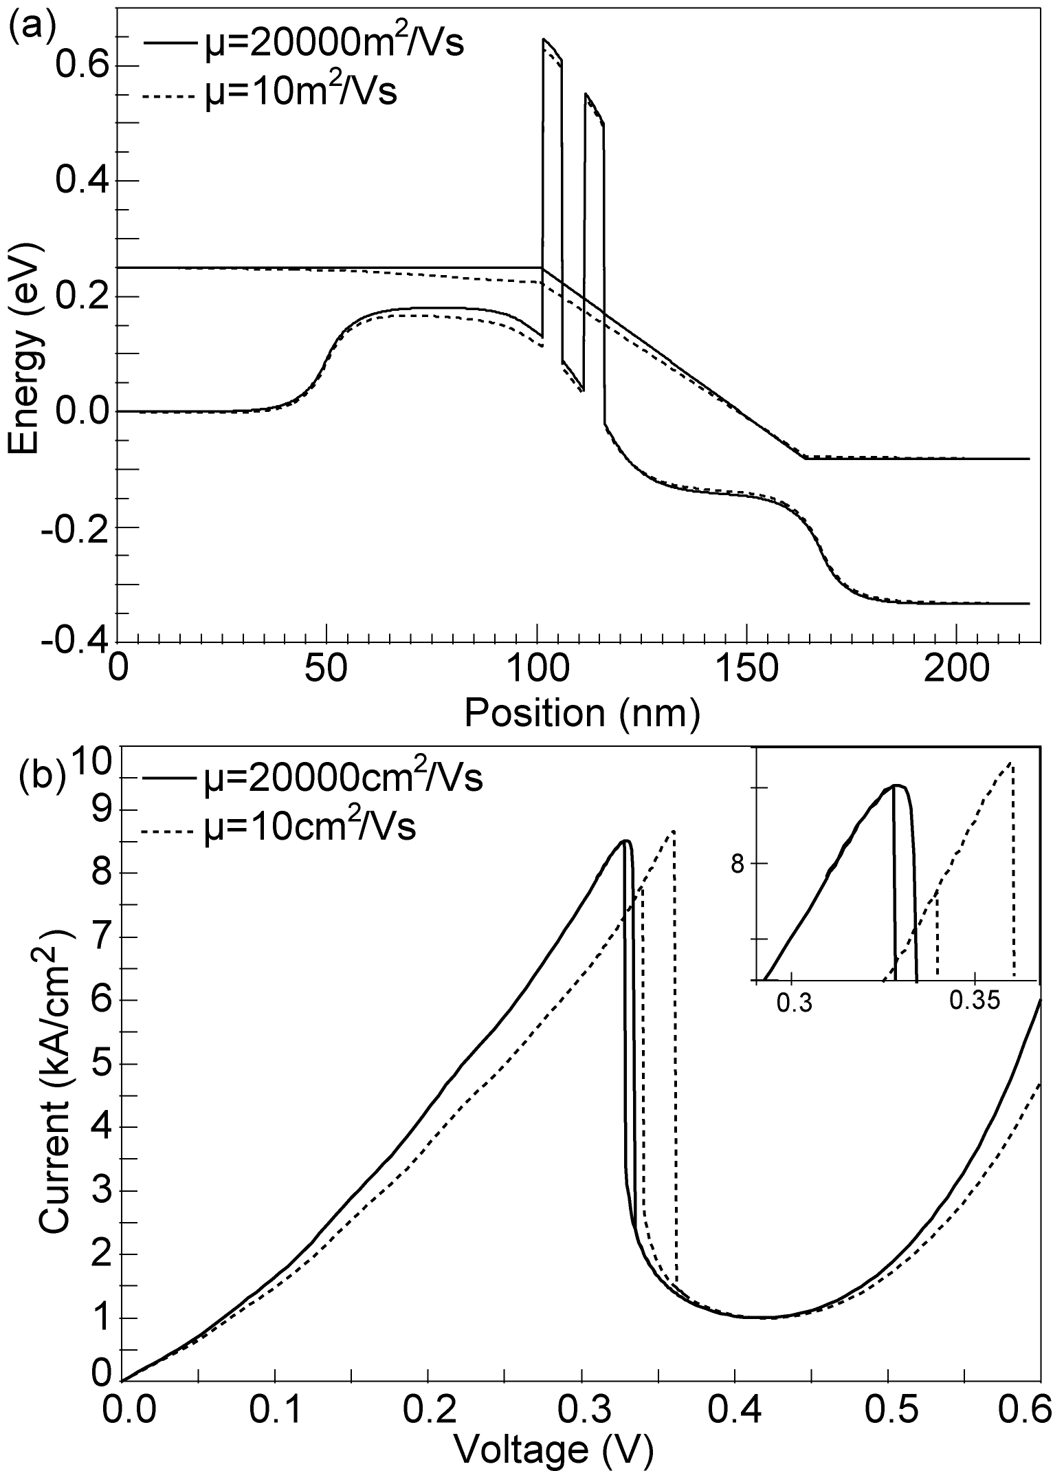
Figure 1: (a) potential profile and quasi Fermi level computed using two different mobilities at an applied bias of 0.333V. The low mobility profile shows a resistive potential drop in the emitter region. (b) Corresponding current-voltage characteristics in forward and reverse sweep. The inset shows the different peak amplitude due to the reduced contact mobility. The region of bi-stability is also increased with decreased mobility similar to a simple series resistance effect.

